Linear Momentum
THE CONCEPT OF linear momentum IS closely tied to the concept of force—in fact, Newton first defined his Second Law not in terms of mass and acceleration, but in terms of momentum. Like energy, linear momentum is a conserved quantity in closed systems, making it a very handy tool for solving problems in mechanics. On the whole, it is useful to analyze systems in terms of energy when there is an exchange of potential energy and kinetic energy. Linear momentum, however, is useful in those cases where there is no clear measure for potential energy. In particular, we will use the law of conservation of momentum to determine the outcome of collisions between two bodies.

What Is Linear Momentum?
Linear momentum is a vector quantity defined as the product of an object’s mass, m, and its velocity, v. Linear momentum is denoted by the letter p and is called “momentum” for short:
Note that a body’s momentum is always in the same direction as its velocity vector. The units of momentum are kg · m/s.
Fortunately, the way that we use the word momentum in everyday life is consistent with the definition of momentum in physics. For example, we say that a BMW driving 20 miles per hour has less momentum than the same car speeding on the highway at 80 miles per hour. Additionally, we know that if a large truck and a BMW travel at the same speed on a highway, the truck has a greater momentum than the BMW, because the truck has greater mass. Our everyday usage reflects the definition given above, that momentum is proportional to mass and velocity.
Linear Momentum and Newton’s Second Law
In Chapter 3, we introduced Newton’s Second Law as F = ma. However, since acceleration can be expressed as , we could equally well express Newton’s Second Law as F = . Substituting p for mv, we find an expression of Newton’s Second Law in terms of momentum:

In fact, this is the form in which Newton first expressed his Second Law. It is more flexible than F = ma because it can be used to analyze systems where not just the velocity, but also the mass of a body changes, as in the case of a rocket burning fuel.

Impulse
The above version of Newton’s Second Law can be rearranged to define the impulse, J, delivered by a constant force, F. Impulse is a vector quantity defined as the product of the force acting on a body and the time interval during which the force is exerted. If the force changes during the time interval, F is the average net force over that time interval. The impulse caused by a force during a specific time interval is equal to the body’s change of momentum during that time interval: impulse, effectively, is a measure of change in momentum.
The unit of impulse is the same as the unit of momentum, kg · m/s.
EXAMPLE
A soccer player kicks a 0.1 kg ball that is initially at rest so that it moves with a velocity of 20 m/s. What is the impulse the player imparts to the ball? If the player’s foot was in contact with the ball for 0.01 s, what was the force exerted by the player’s foot on the ball?

What is the impulse the player imparts to the ball?
Since impulse is simply the change in momentum, we need to calculate the difference between the ball’s initial momentum and its final momentum. Since the ball begins at rest, its initial velocity, and hence its initial momentum, is zero. Its final momentum is:

Because the initial momentum is zero, the ball’s change in momentum, and hence its impulse, is 2 kg · m/s.
What was the force exerted by the player’s foot on the ball?
Impulse is the product of the force exerted and the time interval over which it was exerted. It follows, then, that . Since we have already calculated the impulse and have been given the time interval, this is an easy calculation:

Impulse and Graphs
SAT II Physics may also present you with a force vs. time graph, and ask you to calculate the impulse. There is a single, simple rule to bear in mind for calculating the impulse in force vs. time graphs:
The impulse caused by a force during a specific time interval is equal to the area underneath the force vs. time graph during the same interval.
If you recall, whenever you are asked to calculate the quantity that comes from multiplying the units measured by the y-axis with the units measured by the x-axis, you do so by calculating the area under the graph for the relevant interval.
EXAMPLE
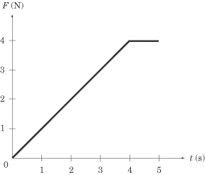
What is the impulse delivered by the force graphed in the figure above between t = 0and t = 5?

The impulse over this time period equals the area of a triangle of height 4 and base 4plus the area of a rectangle of height 4 and width 1. A quick calculation shows us that the impulse is:

Conservation of Momentum
If we combine Newton’s Third Law with what we know about impulse, we can derive the important and extremely useful law of conservation of momentum.
Newton’s Third Law tells us that, to every action, there is an equal and opposite reaction. If object A exerts a force F on object B, then object B exerts a force –F on object A. The net force exerted between objects A and B is zero.
The impulse equation, , tells us that if the net force acting on a system is zero, then the impulse, and hence the change in momentum, is zero. Because the net force between the objects A and B that we discussed above is zero, the momentum of the system consisting of objects A and B does not change.
Suppose object A is a cue ball and object B is an eight ball on a pool table. If the cue ball strikes the eight ball, the cue ball exerts a force on the eight ball that sends it rolling toward the pocket. At the same time, the eight ball exerts an equal and opposite force on the cue ball that brings it to a stop. Note that both the cue ball and the eight ball each experience a change in momentum. However, the sum of the momentum of the cue ball and the momentum of the eight ball remains constant throughout. While the initial momentum of the cue ball, , is not the same as its final momentum, , and the initial momentum of the eight ball, , is not the same as its final momentum, , the initial momentum of the two balls combined is equal to the final momentum of the two balls combined:
The conservation of momentum only applies to systems that have no external forces acting upon them. We call such a system a closed or isolated system: objects within the system may exert forces on other objects within the system (e.g., the cue ball can exert a force on the eight ball and vice versa), but no force can be exerted between an object outside the system and an object within the system. As a result, conservation of momentum does not apply to systems where friction is a factor.
Conservation of Momentum on SAT II Physics
The conservation of momentum may be tested both quantitatively and qualitatively on SAT II Physics. It is quite possible, for instance, that SAT II Physics will contain a question or two that involves a calculation based on the law of conservation of momentum. In such a question, “conservation of momentum” will not be mentioned explicitly, and even “momentum” might not be mentioned. Most likely, you will be asked to calculate the velocity of a moving object after a collision of some sort, a calculation that demands that you apply the law of conservation of momentum.
Alternately, you may be asked a question that simply demands that you identify the law of conservation of momentum and know how it is applied. The first example we will look at is of this qualitative type, and the second example is of a quantitative conservation of momentum question.
EXAMPLE 1
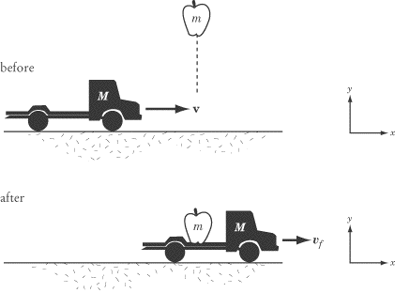
 | An apple of mass m falls into the bed of a moving toy truck of mass M. Before the apple lands in the car, the car is moving at constant velocity v on a frictionless track. Which of the following laws would you use to find the speed of the toy truck after the apple has landed?
 | (A) | Newton’s First Law
 | (B) | Newton’s Second Law
 | (C) | Kinematic equations for constant acceleration
 | (D) | Conservation of mechanical energy
 | (E) | Conservation of linear momentum

Although the title of the section probably gave the solution away, we phrase the problem in this way because you’ll find questions of this sort quite a lot on SAT II Physics. You can tell a question will rely on the law of conservation of momentum for its solution if you are given the initial velocity of an object and are asked to determine its final velocity after a change in mass or a collision with another object.
Some Supplemental Calculations
But how would we use conservation of momentum to find the speed of the toy truck after the apple has landed?
First, note that the net force acting in the x direction upon the apple and the toy truck is zero. Consequently, linear momentum in the x direction is conserved. The initial momentum of the system in the x direction is the momentum of the toy truck,.
Once the apple is in the truck, both the apple and the truck are traveling at the same speed, . Therefore, . Equating and , we find:

As we might expect, the final velocity of the toy truck is less than its initial velocity. As the toy truck gains the apple as cargo, its mass increases and it slows down. Because momentum is conserved and is directly proportional to mass and velocity, any increase in mass must be accompanied by a corresponding decrease in velocity.
EXAMPLE 2
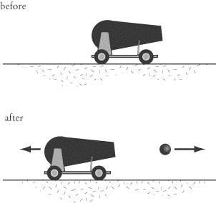
A cannon of mass 1000 kg launches a cannonball of mass 10 kg at a velocity of 100 m/s. At what speed does the cannon recoil?

Questions involving firearms recoil are a common way in which SAT II Physics may test your knowledge of conservation of momentum. Before we dive into the math, let’s get a clear picture of what’s going on here. Initially the cannon and cannonball are at rest, so the total momentum of the system is zero. No external forces act on the system in the horizontal direction, so the system’s linear momentum in this direction is constant. Therefore the momentum of the system both before and after the cannon fires must be zero.
Now let’s make some calculations. When the cannon is fired, the cannonball shoots forward with momentum (10 kg)(100 m/s) = 1000 kg · m/s. To keep the total momentum of the system at zero, the cannon must then recoil with an equal momentum:

Any time a gun, cannon, or an artillery piece releases a projectile, it experiences a “kick” and moves in the opposite direction of the projectile. The more massive the firearm, the slower it moves.

Collisions
A collision occurs when two or more objects hit each other. When objects collide, each object feels a force for a short amount of time. This force imparts an impulse, or changes the momentum of each of the colliding objects. But if the system of particles is isolated, we know that momentum is conserved. Therefore, while the momentum of each individual particle involved in the collision changes, the total momentum of the system remains constant.
The procedure for analyzing a collision depends on whether the process is elastic or inelastic. Kinetic energy is conserved in elastic collisions, whereas kinetic energy is converted into other forms of energy during an inelastic collision. In both types of collisions, momentum is conserved.
Elastic Collisions
Anyone who plays pool has observed elastic collisions. In fact, perhaps you’d better head over to the pool hall right now and start studying! Some kinetic energy is converted into sound energy when pool balls collide—otherwise, the collision would be silent—and a very small amount of kinetic energy is lost to friction. However, the dissipated energy is such a small fraction of the ball’s kinetic energy that we can treat the collision as elastic.
Equations for Kinetic Energy and Linear Momentum
Let’s examine an elastic collision between two particles of mass and , respectively. Assume that the collision is head-on, so we are dealing with only one dimension—you are unlikely to find two-dimensional collisions of any complexity on SAT II Physics. The velocities of the particles before the elastic collision are and , respectively. The velocities of the particles after the elastic collision are and . Applying the law of conservation of kinetic energy, we find:
Applying the law of conservation of linear momentum:
These two equations put together will help you solve any problem involving elastic collisions. Usually, you will be given quantities for , , and , and can then manipulate the two equations to solve for and .
EXAMPLE
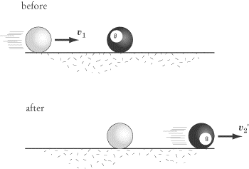
A pool player hits the eight ball, which is initially at rest, head-on with the cue ball. Both of these balls have the same mass, and the velocity of the cue ball is initially . What are the velocities of the two balls after the collision? Assume the collision is perfectly elastic.

Substituting and into the equation for conservation of kinetic energy we find:

Applying the same substitutions to the equation for conservation of momentum, we find:

If we square this second equation, we get:
By subtracting the equation for kinetic energy from this equation, we get:
The only way to account for this result is to conclude that and consequently . In plain English, the cue ball and the eight ball swap velocities: after the balls collide, the cue ball stops and the eight ball shoots forward with the initial velocity of the cue ball. This is the simplest form of an elastic collision, and also the most likely to be tested on SAT II Physics.
Inelastic Collisions
Most collisions are inelastic because kinetic energy is transferred to other forms of energy—such as thermal energy, potential energy, and sound—during the collision process. If you are asked to determine if a collision is elastic or inelastic, calculate the kinetic energy of the bodies before and after the collision. If kinetic energy is not conserved, then the collision is inelastic. Momentum is conserved in all inelastic collisions.
On the whole, inelastic collisions will only appear on SAT II Physics qualitatively. You may be asked to identify a collision as inelastic, but you won’t be expected to calculate the resulting velocities of the objects involved in the collision. The one exception to this rule is in the case of completely inelastic collisions.
Completely Inelastic Collisions
A completely inelastic collision, also called a “perfectly” or “totally” inelastic collision, is one in which the colliding objects stick together upon impact. As a result, the velocity of the two colliding objects is the same after they collide. Because , it is possible to solve problems asking about the resulting velocities of objects in a completely inelastic collision using only the law of conservation of momentum.
EXAMPLE
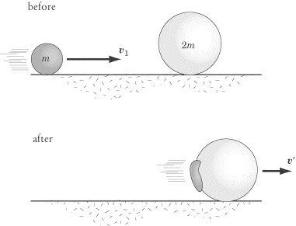
Two gumballs, of mass m and mass 2m respectively, collide head-on. Before impact, the gumball of mass m is moving with a velocity , and the gumball of mass 2m is stationary. What is the final velocity, , of the gumball wad?

First, note that the gumball wad has a mass of m + 2m = 3m. The law of conservation of momentum tells us that , and so . Therefore, the final gumball wad moves in the same direction as the first gumball, but with one-third of its velocity.
Collisions in Two Dimensions
Two-dimensional collisions, while a little more involved than the one-dimensional examples we’ve looked at so far, can be treated in exactly the same way as their one-dimensional counterparts. Momentum is still conserved, as is kinetic energy in the case of elastic collisions. The significant difference is that you will have to break the trajectories of objects down into x- and y-components. You will then be able to deal with the two components separately: momentum is conserved in the x direction, and momentum is conserved in the y direction. Solving a problem of two-dimensional collision is effectively the same thing as solving two problems of one-dimensional collision.
Because SAT II Physics generally steers clear of making you do too much math, it’s unlikely that you’ll be faced with a problem where you need to calculate the final velocities of two objects that collide two-dimensionally. However, questions that test your understanding of two-dimensional collisions qualitatively are perfectly fair game.
EXAMPLE
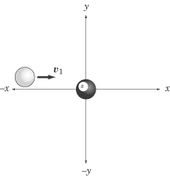
A pool player hits the eight ball with the cue ball, as illustrated above. Both of the billiard balls have the same mass, and the eight ball is initially at rest. Which of the figures below illustrates a possible trajectory of the balls, given that the collision is elastic and both balls move at the same speed?

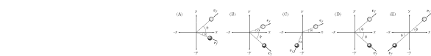
The correct answer choice is D, because momentum is not conserved in any of the other figures. Note that the initial momentum in the y direction is zero, so the momentum of the balls in the y direction after the collision must also be zero. This is only true for choices D and E. We also know that the initial momentum in the xdirection is positive, so the final momentum in the x direction must also be positive, which is not true for E.

Center of Mass
When calculating trajectories and collisions, it’s convenient to treat extended bodies, such as boxes and balls, as point masses. That way, we don’t need to worry about the shape of an object, but can still take into account its mass and trajectory. This is basically what we do with free-body diagrams. We can treat objects, and even systems, as point masses, even if they have very strange shapes or are rotating in complex ways. We can make this simplification because there is always a point in the object or system that has the same trajectory as the object or system as a whole would have if all its mass were concentrated in that point. That point is called the object’s or system’s center of mass.
Consider the trajectory of a diver jumping into the water. The diver’s trajectory can be broken down into the translational movement of his center of mass, and the rotation of the rest of his body about that center of mass.
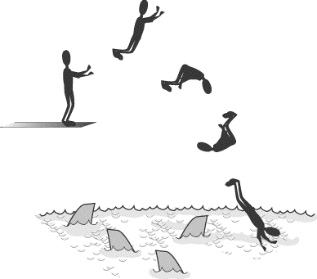
A human being’s center of mass is located somewhere around the pelvic area. We see here that, though the diver’s head and feet and arms can rotate and move gracefully in space, the center of mass in his pelvic area follows the inevitable parabolic trajectory of a body moving under the influence of gravity. If we wanted to represent the diver as a point mass, this is the point we would choose.
Our example suggests that Newton’s Second Law can be rewritten in terms of the motion of the center of mass:
Put in this form, the Second Law states that the net force acting on a system, , is equal to the product of the total mass of the system, M, and the acceleration of the center of mass, . Note that if the net force acting on a system is zero, then the center of mass does not accelerate.
Similarly, the equation for linear momentum can be written in terms of the velocity of the center of mass:
You will probably never need to plug numbers into these formulas for SAT II Physics, but it’s important to understand the principle: the rules of dynamics and momentum apply to systems as a whole just as they do to bodies.
Calculating the Center of Mass
The center of mass of an object of uniform density is the body’s geometric center. Note that the center of mass does not need to be located within the object itself. For example, the center of mass of a donut is in the center of its hole.
For a System of Two Particles
For a collection of particles, the center of mass can be found as follows. Consider two particles of mass and separated by a distance d:
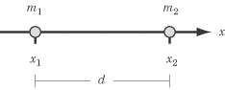
If you choose a coordinate system such that both particles fall on the x-axis, the center of mass of this system, , is defined by:
For a System in One Dimension
We can generalize this definition of the center of mass for a system of n particles on a line. Let the positions of these particles be , , . . ., . To simplify our notation, let M be the total mass of all n particles in the system, meaning . Then, the center of mass is defined by:
For a System in Two Dimensions
Defining the center of mass for a two-dimensional system is just a matter of reducing each particle in the system to its x- and y-components. Consider a system of nparticles in a random arrangement of x-coordinates , , . . . , and y-coordinates , , . . ., . The x-coordinate of the center of mass is given in the equation above, while the y-coordinate of the center of mass is:
How Systems Will Be Tested on SAT II Physics
The formulas we give here for systems in one and two dimensions are general formulas to help you understand the principle by which the center of mass is determined. Rest assured that for SAT II Physics, you’ll never have to plug in numbers for mass and position for a system of several particles. However, your understanding of center of mass may be tested in less mathematically rigorous ways.
For instance, you may be shown a system of two or three particles and asked explicitly to determine the center of mass for the system, either mathematically or graphically. Another example, which we treat below, is that of a system consisting of two parts, where one part moves relative to the other. In this cases, it is important to remember that the center of mass of the system as a whole doesn’t move.
EXAMPLE
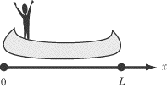
A fisherman stands at the back of a perfectly symmetrical boat of length L. The boat is at rest in the middle of a perfectly still and peaceful lake, and the fisherman has a mass 1/4 that of the boat. If the fisherman walks to the front of the boat, by how much is the boat displaced?

If you’ve ever tried to walk from one end of a small boat to the other, you may have noticed that the boat moves backward as you move forward. That’s because there are no external forces acting on the system, so the system as a whole experiences no net force. If we recall the equation , the center of mass of the system cannot move if there is no net force acting on the system. The fisherman can move, the boat can move, but the system as a whole must maintain the same center of mass. Thus, as the fisherman moves forward, the boat must move backward to compensate for his movement.
Because the boat is symmetrical, we know that the center of mass of the boat is at its geometrical center, at x = L/2. Bearing this in mind, we can calculate the center of mass of the system containing the fisherman and the boat:

Now let’s calculate where the center of mass of the fisherman-boat system is relative to the boat after the fisherman has moved to the front. We know that the center of mass of the fisherman-boat system hasn’t moved relative to the water, so its displacement with respect to the boat represents how much the boat has been displaced with respect to the water.
In the figure below, the center of mass of the boat is marked by a dot, while the center of mass of the fisherman-boat system is marked by an x.
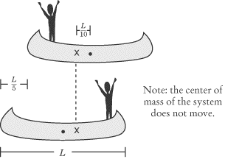
At the front end of the boat, the fisherman is now at position L, so the center of mass of the fisherman-boat system relative to the boat is

The center of mass of the system is now 3 /5 from the back of the boat. But we know the center of mass hasn’t moved, which means the boat has moved backward a distance of 1/5 L, so that the point 3/ 5 L is now located where the point 2 /5 L was before the fisherman began to move.

Key Formulas
Linear Momentum
Impulse of a Constant Force
Conservation of Energy for an Elastic Collision of Two Particles
Conservation of Momentum for a Collision of Two Particles
Center of Mass for a System of n Particles | 
Acceleration of the Center of Mass
Momentum of the Center of Mass

Practice Questions
1. | An athlete of mass 70.0 kg applies a force of 500 N to a 30.0 kg luge, which is initially at rest, over a period of 5.00 s before jumping onto the luge. Assuming there is no friction between the luge and the track on which it runs, what is its velocity after the athlete jumps on?
 | (A) | 12.5 m/s
 | (B) | 25.0 m/s
 | (C) | 35.7 m/s
 | (D) | 83.3 m/s
 | (E) | 100 m/s

 | 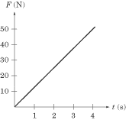
2. | The graph above shows the amount of force applied to an initially stationary 20 kg curling rock over time. What is the velocity of the rock after the force has been applied to it?
 | (A) | 1.25 m/s
 | (B) | 5 m/s
 | (C) | 10 m/s
 | (D) | 25 m/s
 | (E) | 50 m/s

 | 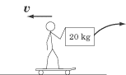
3. | A 60 kg man holding a 20 kg box rides on a skateboard at a speed of 7 m/s. He throws the box behind him, giving it a velocity of 5 m/s. with respect to the ground. What is his velocity after throwing the object?
 | (A) | 8 m/s
 | (B) | 9 m/s
 | (C) | 10 m/s
 | (D) | 11 m/s
 | (E) | 12 m/s

 | 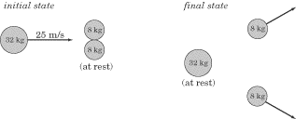
4. | A scattering experiment is done with a 32 kg disc and two 8 kg discs on a frictionless surface. In the initial state of the experiment, the heavier disc moves in the x direction with velocity v = 25 m/s toward the lighter discs, which are at rest. The discs collide elastically. In the final state, the heavy disc is at rest and the two smaller discs scatter outward with the same speed. What is the x-component of the velocity of each of the 8 kg discs in the final state?
 | (A) | 12.5 m/s
 | (B) | 16 m/s
 | (C) | 25 m/s
 | (D) | 50 m/s
 | (E) | 100 m/s

5. | An moving object has kinetic energy KE = 100 J and momentum p = 50 kg Â· m/s. What is its mass?
 | (A) | 2 kg
 | (B) | 4 kg
 | (C) | 6.25 kg
 | (D) | 12.5 kg
 | (E) | 25 kg

 | 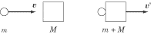
6. | An object of mass m moving with a velocity v collides with another object of mass M. If the two objects stick together, what is their velocity?
 | (A) | 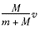
 | (B) | 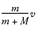
 | (C) | 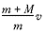
 | (D) | 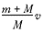
 | (E) | Zero

7. | A body of mass m sliding along a frictionless surface collides with another body of mass m, which is stationary before impact. The two bodies stick together. If the kinetic energy of the two-body system is E, what is the initial velocity of the first mass before impact?
 | (A)
 | (B)
 | (C)
 | (D)
 | (E)

8. | A hockey puck of mass m is initially at rest on a frictionless ice rink. A player comes and hits the puck, imparting an impulse of J. If the puck then collides with another object of mass M at rest and sticks to it, what is the final velocity of the two-body system?
 | (A)
 | (B)
 | (C) | 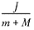
 | (D) | 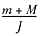
 | (E)

Questions 9 and 10 refer to two 1 kg masses moving toward each other, one mass with velocity = 10 m/s, the other with velocity = 20 m/s.
 | 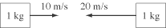
9. | What is the velocity of the center of mass?
 | (A) | 0 m/s
 | (B) | 5 m/s to the left
 | (C) | 10 m/s to the left
 | (D) | 15 m/s to the left
 | (E) | 20 m/s to the left

10. | What is the total energy of the system?
 | (A) | 50 J
 | (B) | 150 J
 | (C) | 200 J
 | (D) | 250 J
 | (E) | 400 J

<< RE

Explanations
1. B
The athlete imparts a certain impulse to the luge over the 5-s period that is equal to . This impulse tells us the change in momentum for the luge. Since the luge starts from rest, this change in momentum gives us the total momentum of the luge:

The total momentum of the luge when the athlete jumps on is 2500 kg · m/s. Momentum is the product of mass and velocity, so we can solve for velocity by dividing momentum by the combined mass of the athlete and the luge:

2. B
The area under a force vs. time graph tells us the impulse given to the rock. Since the rock is motionless at t = 0, the impulse given to the rock is equal to the rock’s total momentum. The area under the graph is a triangle of height 50 N and length 4 s:
Calculating the rock’s velocity, then, is simply a matter of dividing its momentum by its mass:

3. D
This is a conservation of momentum problem. The initial momentum of the system must be equal to the final momentum. The initial momentum of the system is:

The final momentum of the system is the sum of the momentum of the box and of the skateboarder. Since the box is thrown in the opposite direction of the skateboard’s initial momentum, it will have a negative momentum. Because the final momentum and the initial momentum are equal, we know that the final momentum of the skateboarder minus the momentum of the box will equal 560 kg · m/s. With this information, we can solve for v, the skateboarder’s final velocity:

4. D
The law of conservation of linear momentum tells us that the x-component of the system’s momentum must be equal before and after the collision. The x-component of the system’s momentum before the collision is the momentum of the large disc. The x-component of the system’s momentum after the collision is the x-component of the momentum of both of the smaller discs put together. Since momentum is p = mv, and since the larger disc has twice the mass of the two smaller discs put together, that means that the velocity of the two smaller discs must be twice the velocity of the larger disc; that is, 50 m/s.
5. D
We have equations for kinetic energy, KE = 1/2 mv2, and momentum, p = mv, both of which include variables for mass and velocity. If we first solve for velocity, we can then plug that value into the equation and solve for mass:

If v = 4 m/s, then we can plug this value into the equation for momentum to find that p = 4m = 50 kg · m/s, and conclude that m = 12.5 kg.
6. B
The law of conservation of momentum tells us that the initial momentum of the system is equal to the final momentum of the system. The initial momentum is p = mv, and the final momentum is , where is the final velocity of the two objects. Knowing that , we can solve for :

7. E
Momentum is conserved in this collision. If the mass is moving with velocity v before impact and the two-mass system is moving with velocity after impact, we know that . We also know that the kinetic energy of the two-body system is E = 1/2. If we solve for , we find:

From the equation , we can conclude that the initial velocity of the first body, v, is double . If the value for is given in terms of KE in the equation above, then the value of v is simply twice that, .
8. C
Impulse is defined as the change in momentum. Since the hockey puck is initially at rest, its change in momentum is simply its momentum after it has been set in motion. In other words, the momentum of the puck in motion is equal to J.
When the puck collides with the other object, momentum is conserved, so the system of the puck and the other object also has a momentum of J. This momentum is equal to the mass, m + M, of the system, multiplied by the velocity of the two-body system, . Solving for is now quite easy:

9. B
The velocity of the center of mass of the system is the same as the total velocity of the system. To find the total velocity of the system, we need to find the total momentum of the system and divide it by the total mass of the system.
The momentum of the first mass is = 10 kg · m/s to the right, and the momentum of the second mass is = 20 kg · m/s to the left. Therefore, the total momentum of the system is + = 10kg · m/s to the left. Since the total mass of the system is 2 kg, we can find the total velocity of the system by dividing its momentum by its mass:

10. D
The only energy in the system is the kinetic energy of the two masses. These can be determined through two easy calculations:

Adding these two energies together, we find that the total energy of the system is 50 J + 200 J = 250 J.

